- Login
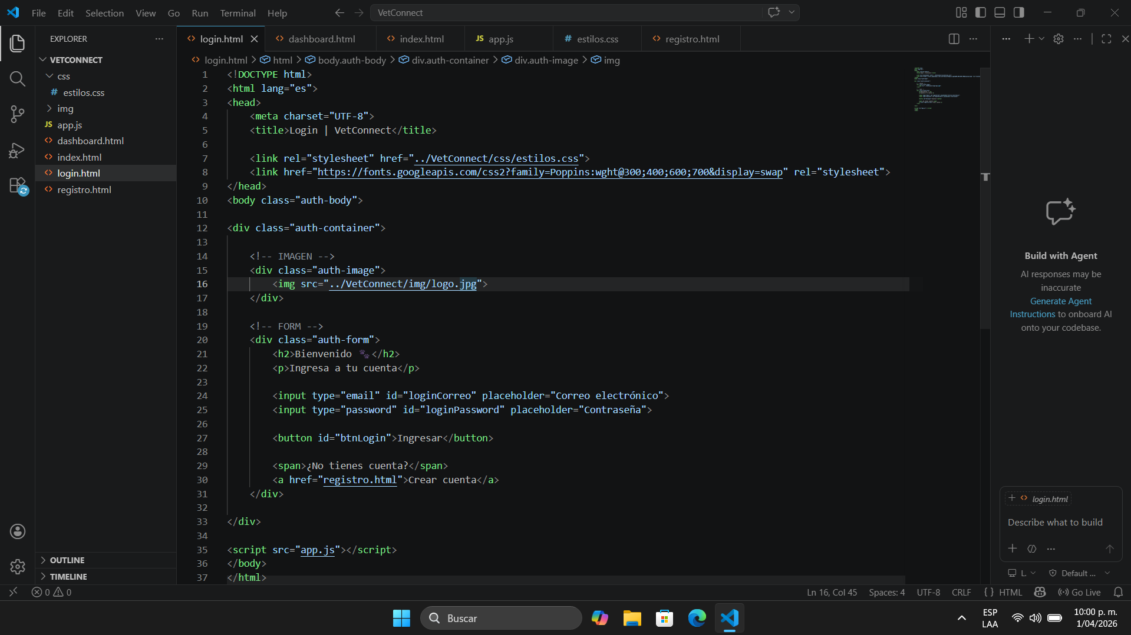
<!DOCTYPE html>
<html lang="es">
<head>
<meta charset="UTF-8">
<title>Login | VetConnect</title>

<link rel="stylesheet" href="../VetConnect/css/estilos.css">
<link href="https://fonts.googleapis.com/css2?family=Poppins:wght@300;400;600;700&display=swap" rel="stylesheet">
</head>
<body class="auth-body">

<div class="auth-container">

<!-- IMAGEN -->
<div class="auth-image">
<img src="../VetConnect/img/logo.jpg">
</div>

<!-- FORM -->
<div class="auth-form">
<h2>Bienvenido 🐾</h2>
<p>Ingresa a tu cuenta</p>

<input type="email" id="loginCorreo" placeholder="Correo electrónico">
<input type="password" id="loginPassword" placeholder="Contraseña">

<button id="btnLogin">Ingresar</button>

<span>¿No tienes cuenta?</span>
<a href="registro.html">Crear cuenta</a>
</div>

</div>

<script src="app.js"></script>
</body>
</html>

- Dashboard
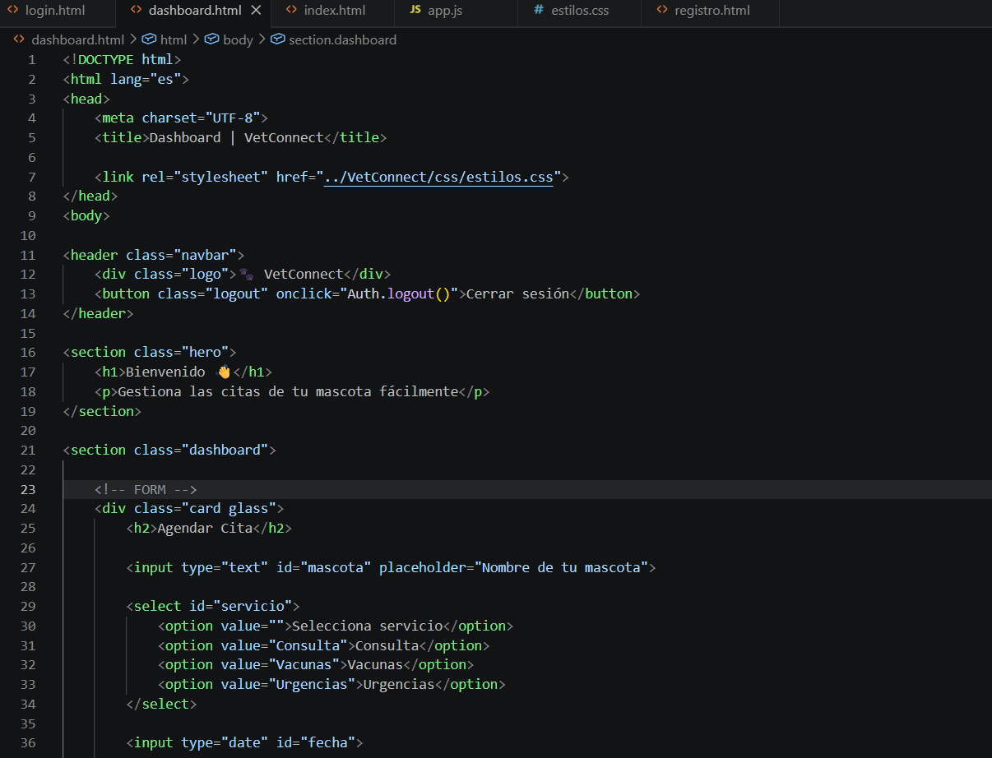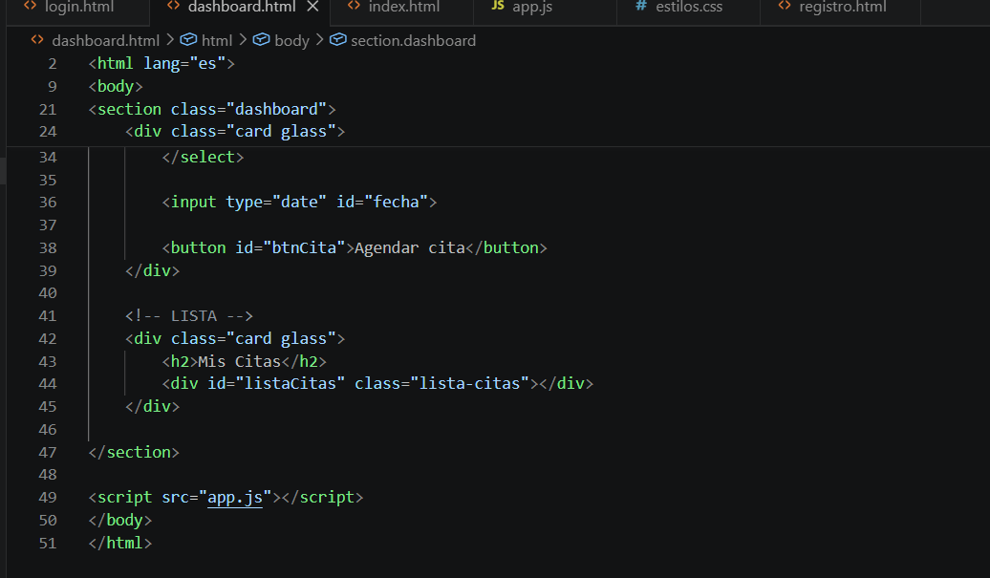
<!DOCTYPE html>
<html lang="es">
<head>
<meta charset="UTF-8">
<title>Dashboard | VetConnect</title>

<link rel="stylesheet" href="../VetConnect/css/estilos.css">
</head>
<body>

<header class="navbar">
<div class="logo">🐾 VetConnect</div>
<button class="logout" onclick="Auth.logout()">Cerrar sesión</button>
</header>

<section class="hero">
<h1>Bienvenido 👋</h1>
<p>Gestiona las citas de tu mascota fácilmente</p>
</section>

<section class="dashboard">

<!-- FORM -->
<div class="card glass">
<h2>Agendar Cita</h2>

<input type="text" id="mascota" placeholder="Nombre de tu mascota">

<select id="servicio">
<option value="">Selecciona servicio</option>
<option value="Consulta">Consulta</option>
<option value="Vacunas">Vacunas</option>
<option value="Urgencias">Urgencias</option>
</select>

<input type="date" id="fecha">

<button id="btnCita">Agendar cita</button>
</div>

<!-- LISTA -->
<div class="card glass">
<h2>Mis Citas</h2>
<div id="listaCitas" class="lista-citas"></div>
</div>

</section>

<script src="app.js"></script>
</body>
</html>

- Index
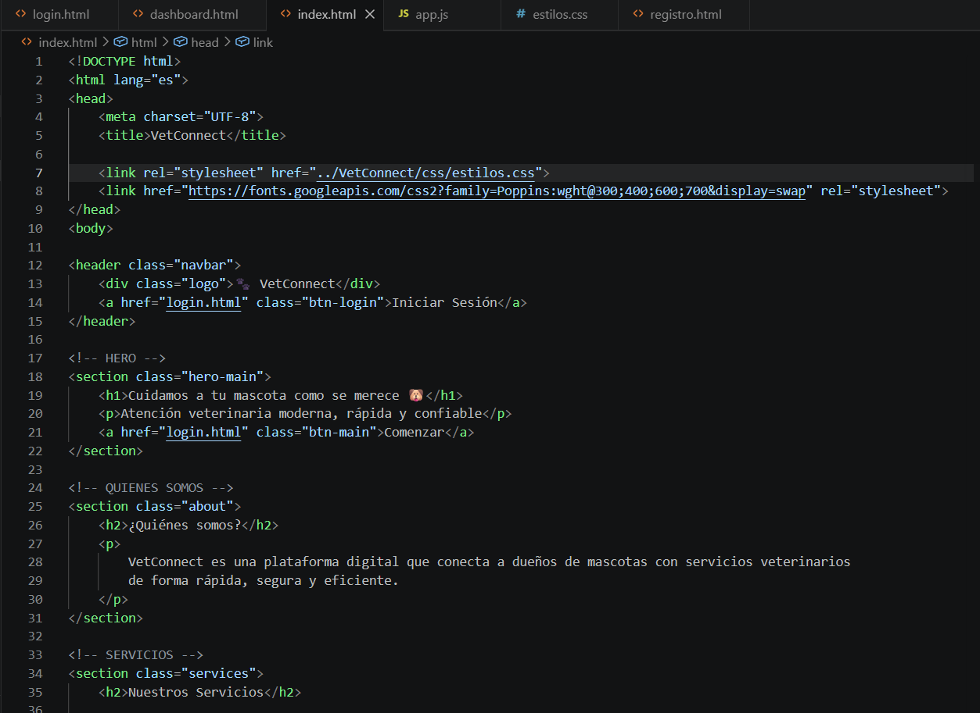
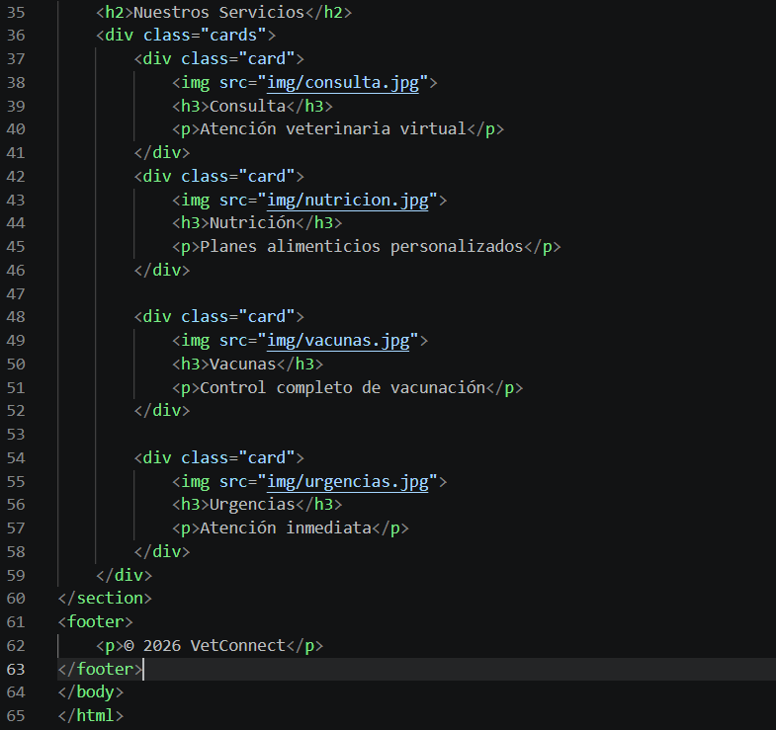
<!DOCTYPE html>
<html lang="es">
<head>
<meta charset="UTF-8">
<title>VetConnect</title>

<link rel="stylesheet" href="../VetConnect/css/estilos.css">
<link href="https://fonts.googleapis.com/css2?family=Poppins:wght@300;400;600;700&display=swap" rel="stylesheet">
</head>
<body>

<header class="navbar">
<div class="logo">🐾 VetConnect</div>
<a href="login.html" class="btn-login">Iniciar Sesión</a>
</header>

<!-- HERO -->
<section class="hero-main">
<h1>Cuidamos a tu mascota como se merece 🐶</h1>
<p>Atención veterinaria moderna, rápida y confiable</p>
<a href="login.html" class="btn-main">Comenzar</a>
</section>

<!-- QUIENES SOMOS -->
<section class="about">
<h2>¿Quiénes somos?</h2>
<p>
VetConnect es una plataforma digital que conecta a dueños de mascotas con servicios veterinarios
de forma rápida, segura y eficiente.
</p>
</section>

<!-- SERVICIOS -->
<section class="services">
<h2>Nuestros Servicios</h2>
<div class="cards">
<div class="card">
<img src="img/consulta.jpg">
<h3>Consulta</h3>
<p>Atención veterinaria virtual</p>
</div>
<div class="card">
<img src="img/nutricion.jpg">
<h3>Nutrición</h3>
<p>Planes alimenticios personalizados</p>
</div>

<div class="card">
<img src="img/vacunas.jpg">
<h3>Vacunas</h3>
<p>Control completo de vacunación</p>
</div>

<div class="card">
<img src="img/urgencias.jpg">
<h3>Urgencias</h3>
<p>Atención inmediata</p>
</div>
</div>
</section>
<footer>
<p>© 2026 VetConnect</p>
</footer>
</body>
</html>

- Registro
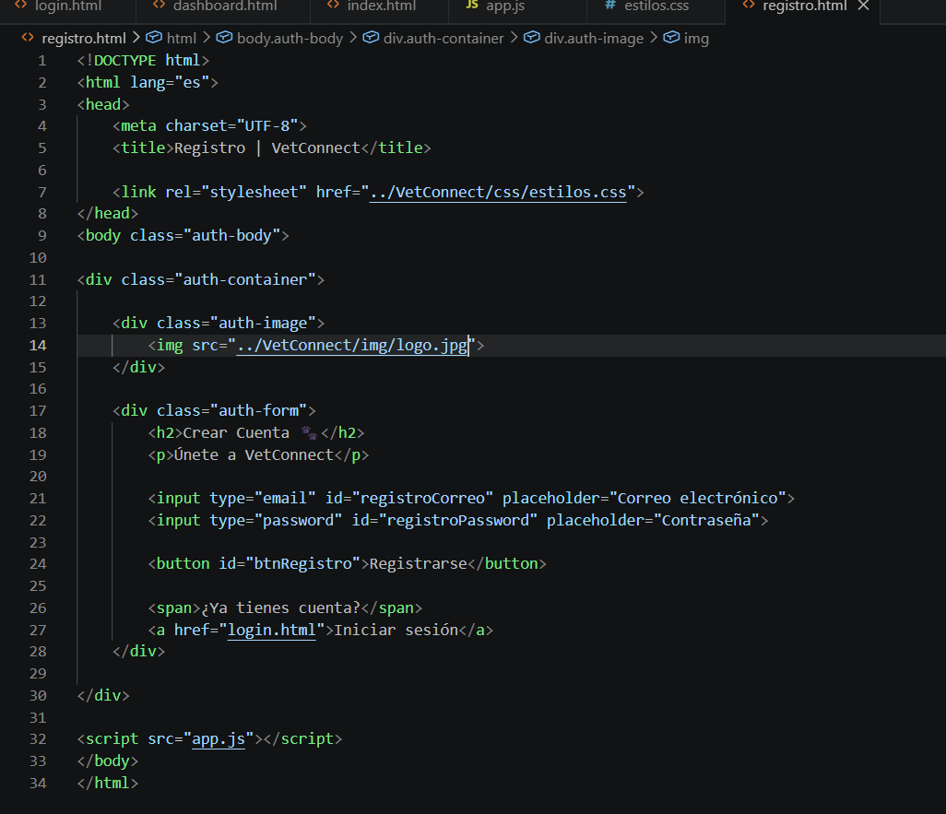
<!DOCTYPE html>
<html lang="es">
<head>
<meta charset="UTF-8">
<title>Registro | VetConnect</title>

<link rel="stylesheet" href="../VetConnect/css/estilos.css">
</head>
<body class="auth-body">

<div class="auth-container">

<div class="auth-image">
<img src="../VetConnect/img/logo.jpg">
</div>

<div class="auth-form">
<h2>Crear Cuenta 🐾</h2>
<p>Únete a VetConnect</p>

<input type="email" id="registroCorreo" placeholder="Correo electrónico">
<input type="password" id="registroPassword" placeholder="Contraseña">

<button id="btnRegistro">Registrarse</button>

<span>¿Ya tienes cuenta?</span>
<a href="login.html">Iniciar sesión</a>
</div>

</div>

<script src="app.js"></script>
</body>
</html>

- Estilos
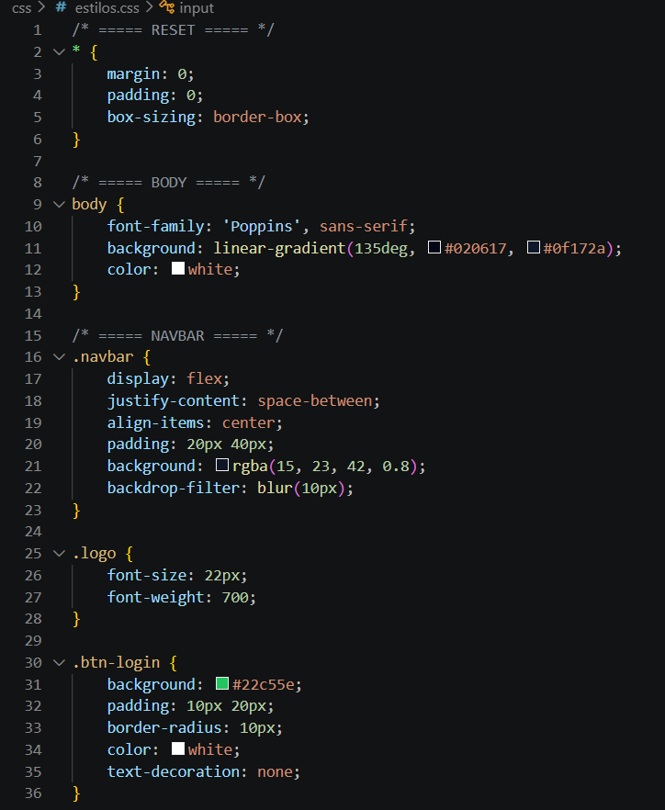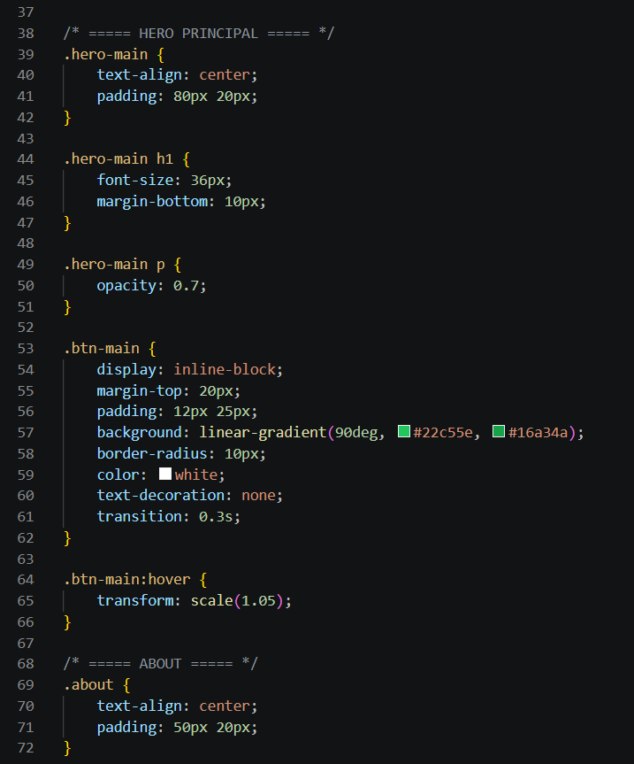
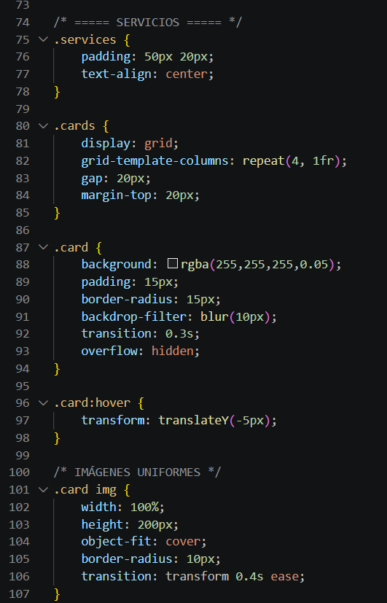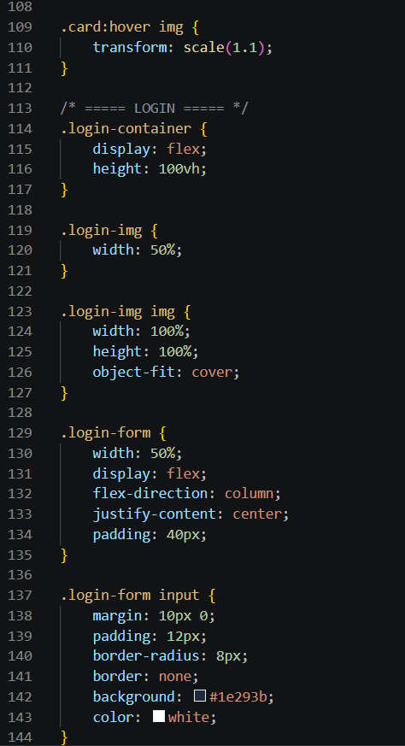

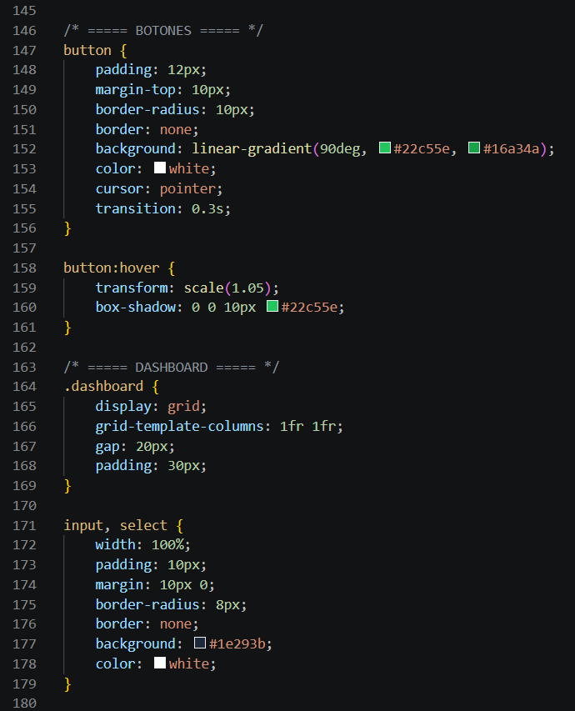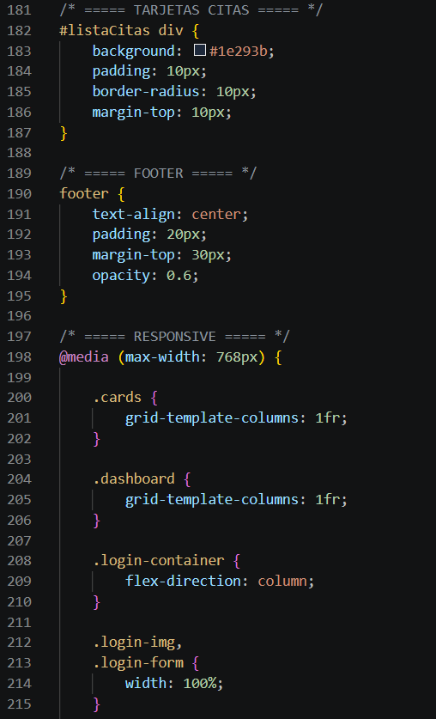
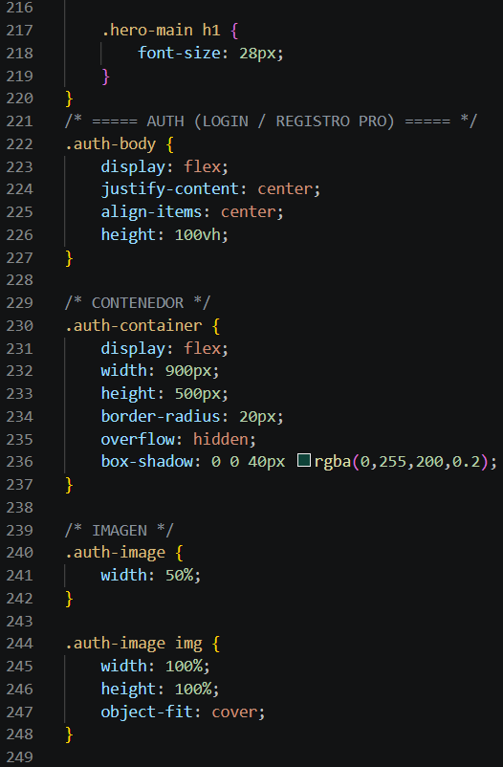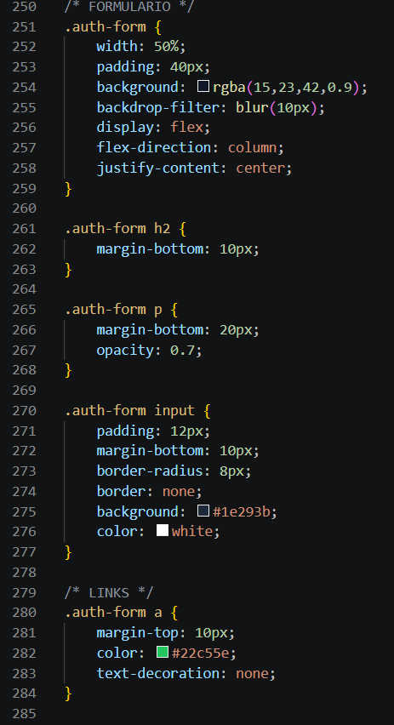

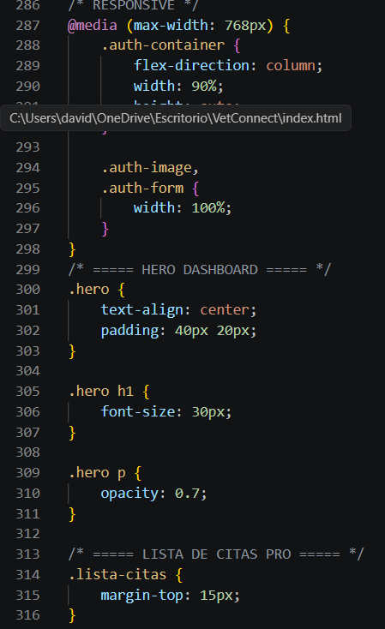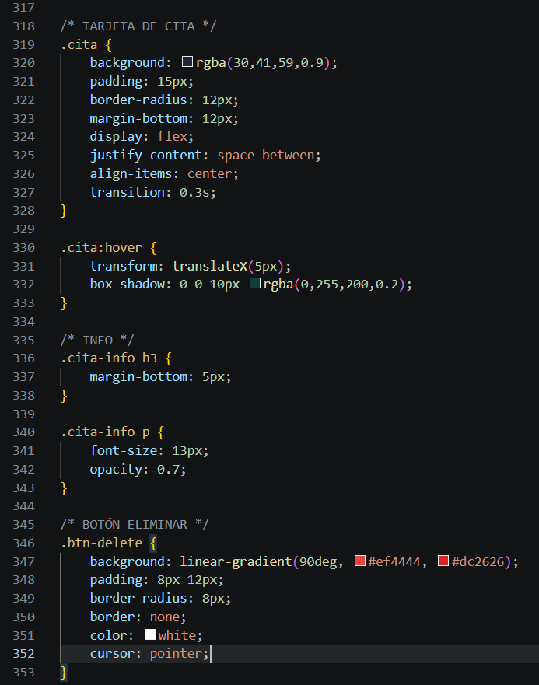
/* ===== RESET ===== */
* {
margin: 0;
padding: 0;
box-sizing: border-box;
}

/* ===== BODY ===== */
body {
font-family: 'Poppins', sans-serif;
background: linear-gradient(135deg, #020617, #0f172a);
color: white;
}

/* ===== NAVBAR ===== */
.navbar {
display: flex;
justify-content: space-between;
align-items: center;
padding: 20px 40px;
background: rgba(15, 23, 42, 0.8);
backdrop-filter: blur(10px);
}

.logo {
font-size: 22px;
font-weight: 700;
}

.btn-login {
background: #22c55e;
padding: 10px 20px;
border-radius: 10px;
color: white;
text-decoration: none;
}

/* ===== HERO PRINCIPAL ===== */
.hero-main {
text-align: center;
padding: 80px 20px;
}

.hero-main h1 {
font-size: 36px;
margin-bottom: 10px;
}

.hero-main p {
opacity: 0.7;
}

.btn-main {
display: inline-block;
margin-top: 20px;
padding: 12px 25px;
background: linear-gradient(90deg, #22c55e, #16a34a);
border-radius: 10px;
color: white;
text-decoration: none;
transition: 0.3s;
}

.btn-main:hover {
transform: scale(1.05);
}

/* ===== ABOUT ===== */
.about {
text-align: center;
padding: 50px 20px;
}

/* ===== SERVICIOS ===== */
.services {
padding: 50px 20px;
text-align: center;
}

.cards {
display: grid;
grid-template-columns: repeat(4, 1fr);
gap: 20px;
margin-top: 20px;
}

.card {
background: rgba(255,255,255,0.05);
padding: 15px;
border-radius: 15px;
backdrop-filter: blur(10px);
transition: 0.3s;
overflow: hidden;
}

.card:hover {
transform: translateY(-5px);
}

/* IMÁGENES UNIFORMES */
.card img {
width: 100%;
height: 200px;
object-fit: cover;
border-radius: 10px;
transition: transform 0.4s ease;
}

.card:hover img {
transform: scale(1.1);
}

/* ===== LOGIN ===== */
.login-container {
display: flex;
height: 100vh;
}

.login-img {
width: 50%;
}

.login-img img {
width: 100%;
height: 100%;
object-fit: cover;
}

.login-form {
width: 50%;
display: flex;
flex-direction: column;
justify-content: center;
padding: 40px;
}

.login-form input {
margin: 10px 0;
padding: 12px;
border-radius: 8px;
border: none;
background: #1e293b;
color: white;
}

/* ===== BOTONES ===== */
button {
padding: 12px;
margin-top: 10px;
border-radius: 10px;
border: none;
background: linear-gradient(90deg, #22c55e, #16a34a);
color: white;
cursor: pointer;
transition: 0.3s;
}

button:hover {
transform: scale(1.05);
box-shadow: 0 0 10px #22c55e;
}

/* ===== DASHBOARD ===== */
.dashboard {
display: grid;
grid-template-columns: 1fr 1fr;
gap: 20px;
padding: 30px;
}

input, select {
width: 100%;
padding: 10px;
margin: 10px 0;
border-radius: 8px;
border: none;
background: #1e293b;
color: white;
}

/* ===== TARJETAS CITAS ===== */
#listaCitas div {
background: #1e293b;
padding: 10px;
border-radius: 10px;
margin-top: 10px;
}

/* ===== FOOTER ===== */
footer {
text-align: center;
padding: 20px;
margin-top: 30px;
opacity: 0.6;
}

/* ===== RESPONSIVE ===== */
@media (max-width: 768px) {

.cards {
grid-template-columns: 1fr;
}

.dashboard {
grid-template-columns: 1fr;
}

.login-container {
flex-direction: column;
}

.login-img,
.login-form {
width: 100%;
}

.hero-main h1 {
font-size: 28px;
}
}
/* ===== AUTH (LOGIN / REGISTRO PRO) ===== */
.auth-body {
display: flex;
justify-content: center;
align-items: center;
height: 100vh;
}

/* CONTENEDOR */
.auth-container {
display: flex;
width: 900px;
height: 500px;
border-radius: 20px;
overflow: hidden;
box-shadow: 0 0 40px rgba(0,255,200,0.2);
}

/* IMAGEN */
.auth-image {
width: 50%;
}

.auth-image img {
width: 100%;
height: 100%;
object-fit: cover;
}

/* FORMULARIO */
.auth-form {
width: 50%;
padding: 40px;
background: rgba(15,23,42,0.9);
backdrop-filter: blur(10px);
display: flex;
flex-direction: column;
justify-content: center;
}

.auth-form h2 {
margin-bottom: 10px;
}

.auth-form p {
margin-bottom: 20px;
opacity: 0.7;
}

.auth-form input {
padding: 12px;
margin-bottom: 10px;
border-radius: 8px;
border: none;
background: #1e293b;
color: white;
}

/* LINKS */
.auth-form a {
margin-top: 10px;
color: #22c55e;
text-decoration: none;
}

/* RESPONSIVE */
@media (max-width: 768px) {
.auth-container {
flex-direction: column;
width: 90%;
height: auto;
}

.auth-image,
.auth-form {
width: 100%;
}
}
/* ===== HERO DASHBOARD ===== */
.hero {
text-align: center;
padding: 40px 20px;
}

.hero h1 {
font-size: 30px;
}

.hero p {
opacity: 0.7;
}

/* ===== LISTA DE CITAS PRO ===== */
.lista-citas {
margin-top: 15px;
}

/* TARJETA DE CITA */
.cita {
background: rgba(30,41,59,0.9);
padding: 15px;
border-radius: 12px;
margin-bottom: 12px;
display: flex;
justify-content: space-between;
align-items: center;
transition: 0.3s;
}

.cita:hover {
transform: translateX(5px);
box-shadow: 0 0 10px rgba(0,255,200,0.2);
}

/* INFO */
.cita-info h3 {
margin-bottom: 5px;
}

.cita-info p {
font-size: 13px;
opacity: 0.7;
}

/* BOTÓN ELIMINAR */
.btn-delete {
background: linear-gradient(90deg, #ef4444, #dc2626);
padding: 8px 12px;
border-radius: 8px;
border: none;
color: white;
cursor: pointer;
}

- App
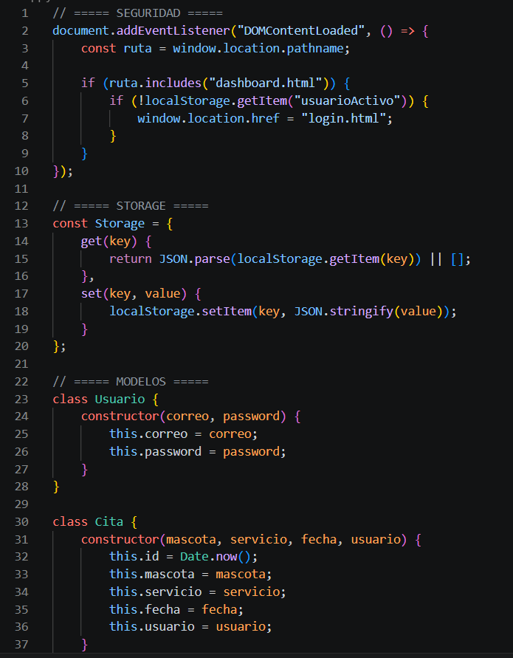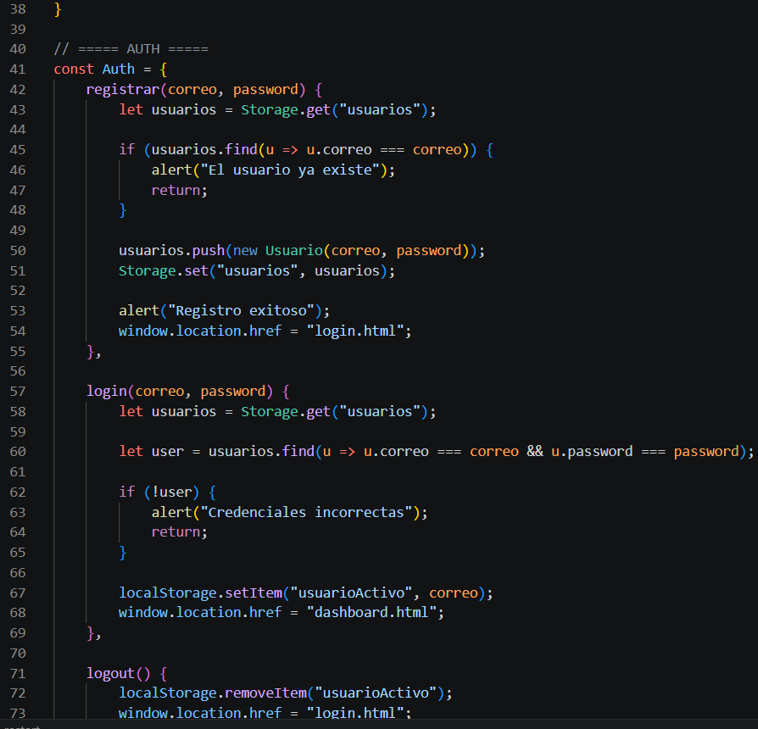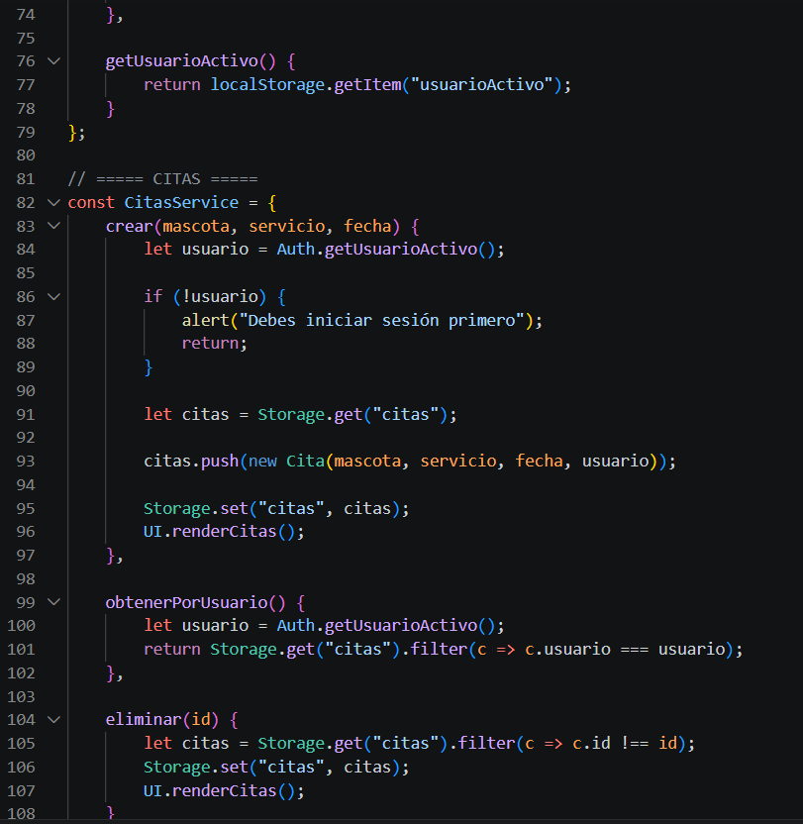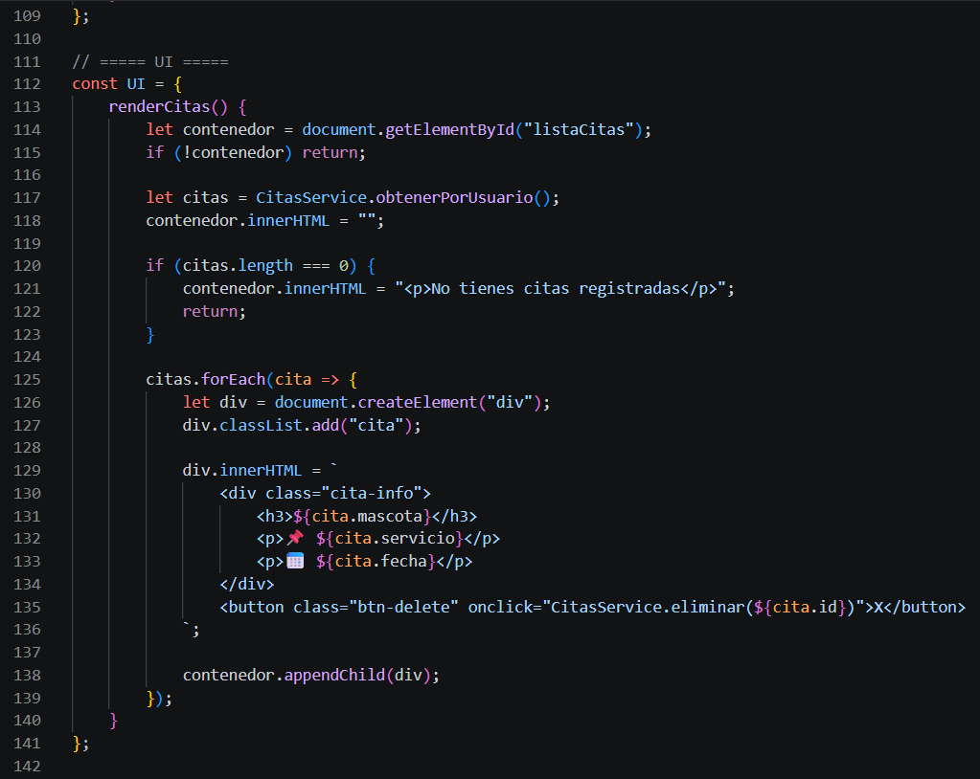
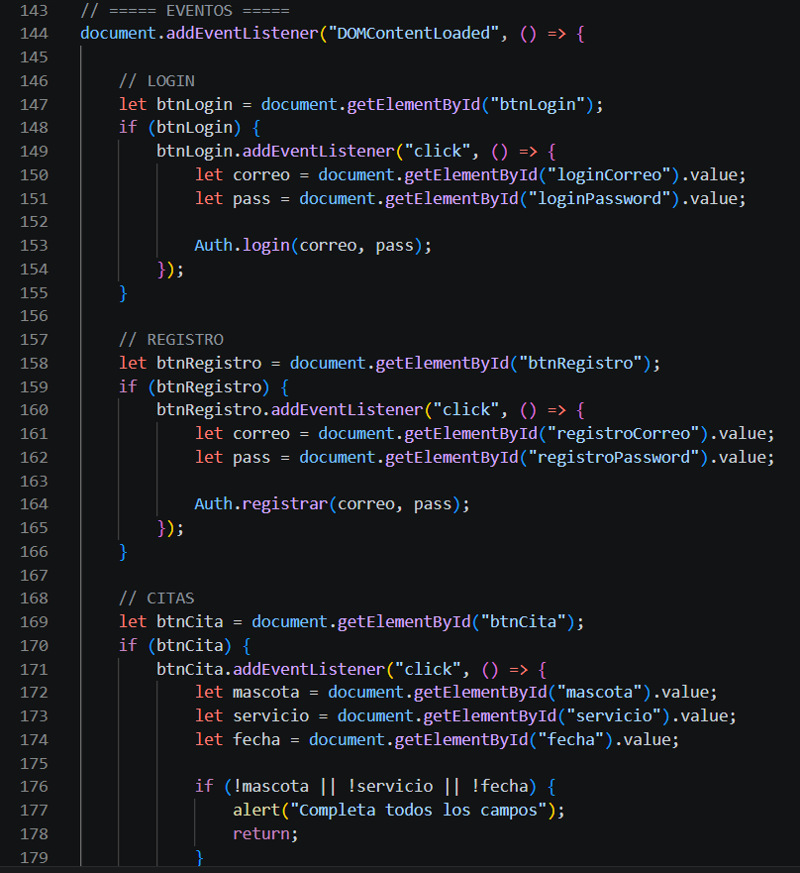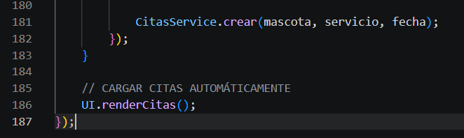
// ===== SEGURIDAD =====
document.addEventListener("DOMContentLoaded", () => {
const ruta = window.location.pathname;

if (ruta.includes("dashboard.html")) {
if (!localStorage.getItem("usuarioActivo")) {
window.location.href = "login.html";
}
}
});

// ===== STORAGE =====
const Storage = {
get(key) {
return JSON.parse(localStorage.getItem(key)) || [];
},
set(key, value) {
localStorage.setItem(key, JSON.stringify(value));
}
};

// ===== MODELOS =====
class Usuario {
constructor(correo, password) {
this.correo = correo;
this.password = password;
}
}

class Cita {
constructor(mascota, servicio, fecha, usuario) {
this.id = Date.now();
this.mascota = mascota;
this.servicio = servicio;
this.fecha = fecha;
this.usuario = usuario;
}
}

// ===== AUTH =====
const Auth = {
registrar(correo, password) {
let usuarios = Storage.get("usuarios");

if (usuarios.find(u => u.correo === correo)) {
alert("El usuario ya existe");
return;
}

usuarios.push(new Usuario(correo, password));
Storage.set("usuarios", usuarios);

alert("Registro exitoso");
window.location.href = "login.html";
},

login(correo, password) {
let usuarios = Storage.get("usuarios");

let user = usuarios.find(u => u.correo === correo && u.password === password);

if (!user) {
alert("Credenciales incorrectas");
return;
}

localStorage.setItem("usuarioActivo", correo);
window.location.href = "dashboard.html";
},

logout() {
localStorage.removeItem("usuarioActivo");
window.location.href = "login.html";
},

getUsuarioActivo() {
return localStorage.getItem("usuarioActivo");
}
};

// ===== CITAS =====
const CitasService = {
crear(mascota, servicio, fecha) {
let usuario = Auth.getUsuarioActivo();

if (!usuario) {
alert("Debes iniciar sesión primero");
return;
}

let citas = Storage.get("citas");

citas.push(new Cita(mascota, servicio, fecha, usuario));

Storage.set("citas", citas);
UI.renderCitas();
},

obtenerPorUsuario() {
let usuario = Auth.getUsuarioActivo();
return Storage.get("citas").filter(c => c.usuario === usuario);
},

eliminar(id) {
let citas = Storage.get("citas").filter(c => c.id !== id);
Storage.set("citas", citas);
UI.renderCitas();
}
};

// ===== UI =====
const UI = {
renderCitas() {
let contenedor = document.getElementById("listaCitas");
if (!contenedor) return;

let citas = CitasService.obtenerPorUsuario();
contenedor.innerHTML = "";

if (citas.length === 0) {
contenedor.innerHTML = "<p>No tienes citas registradas</p>";
return;
}

citas.forEach(cita => {
let div = document.createElement("div");
div.classList.add("cita");

div.innerHTML = `
<div class="cita-info">
<h3>${cita.mascota}</h3>
<p>📌 ${cita.servicio}</p>
<p>📅 ${cita.fecha}</p>
</div>
<button class="btn-delete" onclick="CitasService.eliminar(${cita.id})">X</button>
`;

contenedor.appendChild(div);
});
}
};

// ===== EVENTOS =====
document.addEventListener("DOMContentLoaded", () => {

// LOGIN
let btnLogin = document.getElementById("btnLogin");
if (btnLogin) {
btnLogin.addEventListener("click", () => {
let correo = document.getElementById("loginCorreo").value;
let pass = document.getElementById("loginPassword").value;

Auth.login(correo, pass);
});
}

// REGISTRO
let btnRegistro = document.getElementById("btnRegistro");
if (btnRegistro) {
btnRegistro.addEventListener("click", () => {
let correo = document.getElementById("registroCorreo").value;
let pass = document.getElementById("registroPassword").value;

Auth.registrar(correo, pass);
});
}

// CITAS
let btnCita = document.getElementById("btnCita");
if (btnCita) {
btnCita.addEventListener("click", () => {
let mascota = document.getElementById("mascota").value;
let servicio = document.getElementById("servicio").value;
let fecha = document.getElementById("fecha").value;

if (!mascota || !servicio || !fecha) {
alert("Completa todos los campos");
return;
}

CitasService.crear(mascota, servicio, fecha);
});
}

// CARGAR CITAS AUTOMÁTICAMENTE
UI.renderCitas();
});

